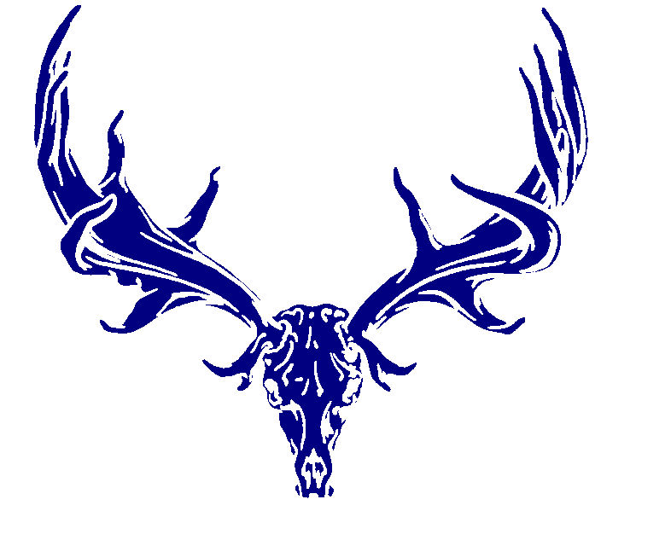

THE IRISH NATURALISTS’ JOURNAL GRANT
APPLICATION FORM 2022

Name of applicant (individual/group/ organisation)
Contact name (if different from above)
Address

Email
Phone number

General purpose of application
Research
Publication
Attendance at conference or workshop
Training course organisation
Other (please briefly specify)

Project / survey details

Title

Sum requested

Aims
[max. 100 words]

Brief description
[max. 300 words]
Outputs, including publications, data sharing, public awareness/outreach plan
[max. 300 words]

Experience of the applicant relevant to the project
[a list of publications / reports may be appended]

Applicant’s current position and how project relates to this
Justification and detailed breakdown of costs (add more rows if required):
Item | Description | Cost (incl. VAT)
Total cost:
Where specialist equipment is requested, please give details of ownership and use of the equipment once the project ends
Where this project is part of a wider project/initiative, please state why INJ funding is required
Details of project affiliates, i.e. contact name(s) and position(s) of associated individuals/groups/organisations
Permissions/licences required
Anticipated duration and completion date

Declaration of assurance from applicant (lead contact)
I declare that I have read and accept the terms and conditions that apply to the grant; that all information provided is true and correct at the time of submission; that all licences and permissions that may be required are/will be in place at the time of the project commencement; and that all project affiliates have been informed of plans and consent to the application. Contact details of all project affiliates must be included in your application. All project affiliates must be included as recipients in your email when the application is being submitted to INJ.

SIGNED BY:
Name and Title Date

Personal Data: The Irish Naturalists’ Journal Ltd. is fully committed to transparency and ensuring the privacy and security of your data. Personal data are collected and processed as legislated in the General Data Protection Regulation (GDPR) (EU) 2016/679. INJ is registered in Northern Ireland and while the UK has left the EU, there is a transition period during which the GDPR will continue to apply in the UK. We only use your data for INJ business and do not pass it on to third parties.

Completing this form: Full details online at https://irishnaturalistsjournal.org/inj-grant/

